**Ideation Phase**

**Brainstorm & Idea Prioritization Template**

|  |  |
| --- | --- |
| Date | 21 OCTOBER 2022 |
| Team ID | PNT2022TMID03634 |
| Project Name | Project - Smart Waste Management For Metropolitan Cities |
| Maximum Marks | 4 Marks |

**Brainstorm & Idea Prioritization Template:**

During a brainstorming session, everyone on a team is encouraged to engage in the process of original thought that results in problem solving. Volume over quality is prioritised, unconventional ideas are welcomed and developed upon, and everyone is urged to participate in order to produce a wealth of original solutions.

Use this template in your own brainstorming sessions so your team can unleash their imagination and start shaping concepts even if you're not sitting in the same room.

Reference: <https://www.mural.co/templates/empathy-map-canvas>

**Step-1: Team Gathering, Collaboration and Select the Problem Statement**

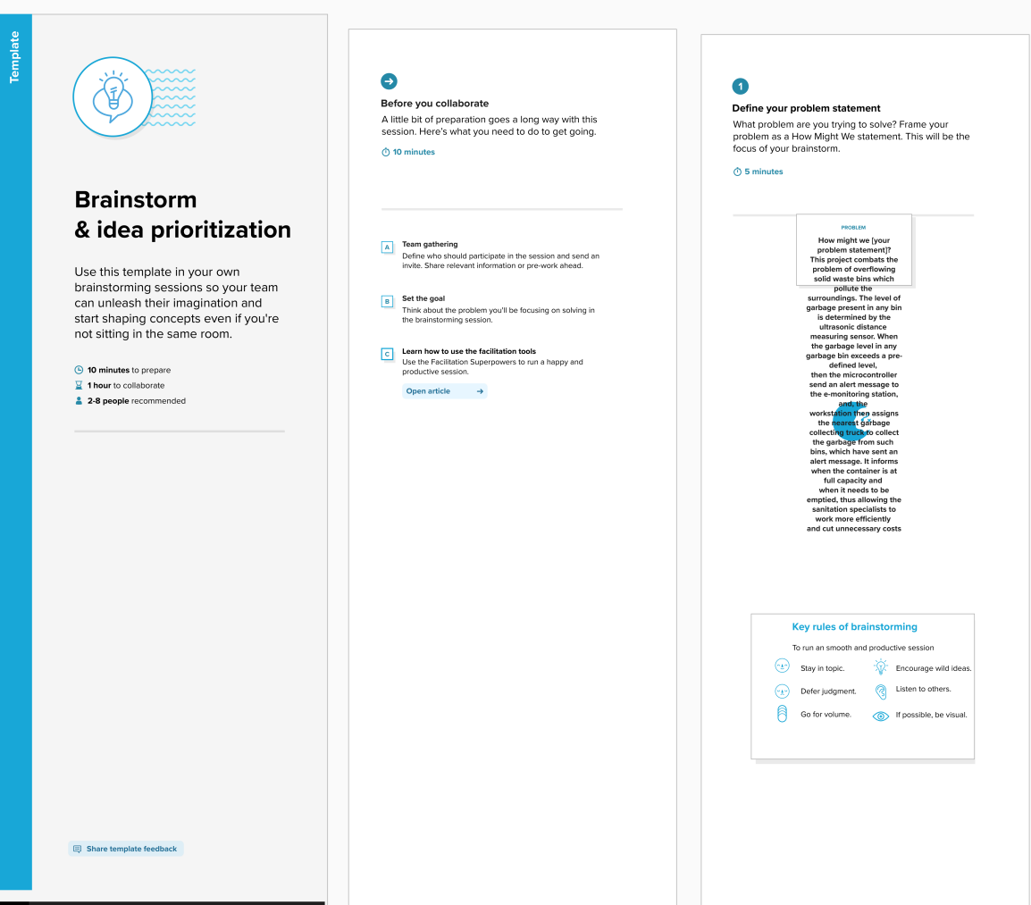

**Step-2: Brainstorm, Idea Listing and Grouping**

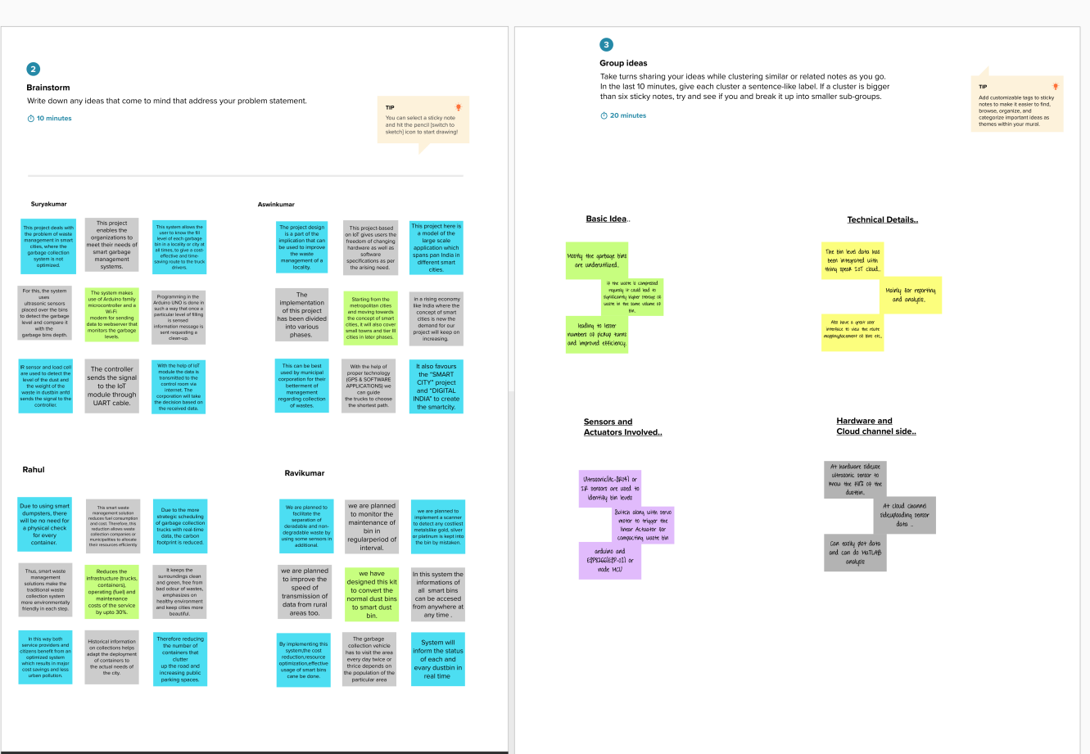

**Step-3: Idea Prioritization**

